**TOK COMMENTARY**

**Prompt 5: What counts as good evidence for a claim?**

**Theme: Knowledge and Technology**

The following commentary explores how certain evidence might not be or might be enough to justify a claim. I will show how the interaction of justification, perspectives and real-world examples can create strong or weak evidence for a claim, while exploring the theme, knowledge and technology.

**Object 1: Iran 2007 Fauxtography Scam**[1]

**­**

This is an image that Iran digitally manipulated in 2007. It claimed the presence of US weapons in their country, and to justify their claim, they sent the above image. Some people may interpret the image to be true, but there is evidence that the image is false.

Though images seem to speak the truth and are considered as good evidence for a claim, the power of digital manipulation proves this wrong. The only justification Iran has for their claim is the label “USA” on all the white weapon boxes. This justification is very vague and does not have any other sources of evidence. We observe that there are multiple white weapon boxes with the label “USA” that have been duplicated all over the image. The same can be said about the green-colored bags and grenades in the image. Additionally, there is no proper evidence that the other weaponry in the image is from USA as there is no label on the other weapons.

This object enhances the commentary as it allows us to realize that good justification for a claim comes only when an image has other sources of evidence. Iran’s only evidence was the USA label on the weaponry. Iran was using identification as evidence, which is bad evidence.

It can also be said that bad evidence for a claim is when better justification that the claim is false is identified. In this case, there is good evidence that the claim is false. This is because it can clearly be seen that the image was digitally altered and how it was digitally altered. Since there is a good justification that Iran’s initial claim is false, the initial claim is proved as bad evidence for a claim.

**Object 2: Facebook post by Mark Zuckerberg**[2]

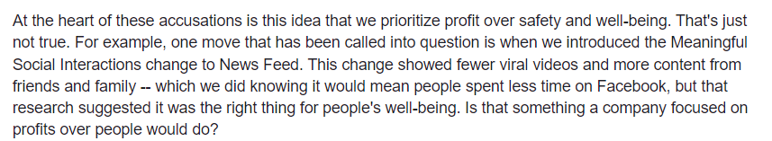

The Facebook post above is a part of a message sent by Mark Zuckerberg on 5th October 2021. The message was sent after the Facebook whistleblower testimony[3] to clear the controversy around Facebook after the testimony. In this message, Zuckerberg claims that Facebook does not prioritize profit over safety and well-being. The justification he gave was when they introduced the Meaningful Social Interactions change to News Feed. Is this enough of a justification? No, it is not as his claim does not take multiple perspectives into account. Though Facebook may have tried to do something about the safety and well-being of people that use the app, there are several other features the app uses to exploit people’s brains. For example, the swipe up for *refresh* feature, double tap to *like* feature and their social media algorithm, all go against this as they try to take advantage of the brain’s vulnerabilities. [4]

This object refines the commentary as it helps us understand that for a message to be considered good evidence, what a person says also has to correspond with other projects the company undertakes. Though there is one example of Facebook using their power to increase safety and well-being, there are several other instances where it does not. This means for a claim to be considered good evidence, just few justifications are not enough. The justifications given must also correspond to other projects the company or person undertakes.

Since Facebook fails to have several other features that support their claim, Zuckerberg’s initial statement that Facebook does not prioritize profit over safety and well-being is proved wrong due to insufficient evidence.

**Object 3: Book Digital Minimalism by Cal Newport**[5]

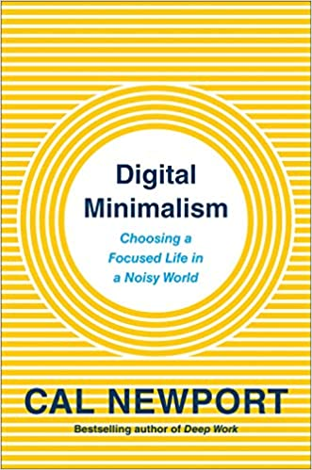

The third object is a book named *Digital Minimalism* by Cal Newport[6] published on 5th February 2019. It provides as a guide to reduce screen time on technology. In the book the author claims the best possible way to reduce screen time on technology, is using his philosophy known as “digital minimalism”. After reading the book, I was convinced that his claims on digital minimalism were correct. Usually, I do not quickly believe things written in books, but I pondered upon why I found this particular book convincing in its evidence.

I realized the author has an interesting manner in which he convinces his audience. The author has a three-step process. First, he gives reasons as to why social media is addicting and harmful to humans. Then, he proceeds to introduce what his philosophy is, and gives techniques on how to practice his philosophy. What is particularly interesting about the way he justifies his claims is the usage of real-world examples. Whenever the author introduces a technique, he gives an example of a person using this technique in their daily life. This convinces the reader that the technique may in fact also work for them, as it has been tested by other people. Additionally, his real-life examples were all from a digital detox he hosted with over 1000 participants. This allows him to take multiple perspectives into consideration. This book provides good evidence for its claims.

This shows that good evidence for a claim happens when claims are paired with real-life examples that take multiple perspectives into account. If a claim is not paired with the said criteria and does not have other means of justification, it cannot be considered as good evidence.

From the analysis of all three objects above we understand that bad evidence for claims come when there is better evidence that the claim is false or when the evidence does not correspond with other projects undertaken. Good evidence comes when real-life examples are used along with multiple perspectives.

Word count: 949 words

Bibliography –

<https://www.amazon.com/Digital-Minimalism-Choosing-Focused-Noisy/dp/0525542876/ref=sr_1_5?crid=2VWHAYOECP9PJ&keywords=digital+minimalism&qid=1651985106&sprefix=digital+minimali%2Caps%2C311&sr=8-5>

<https://www.calnewport.com/>

<https://www.facebook.com/zuck/posts/i-wanted-to-share-a-note-i-wrote-to-everyone-at-our-company-hey-everyone-its-bee/10113961365418581/>

<https://www.imediaethics.org/little-green-footballs-lgf-on-irans-previous-2007-fauxtography-scam/>

<https://www.theguardian.com/technology/2021/oct/06/mark-zuckerberg-hits-back-at-facebook-whistleblower-frances-haugen-claims>

1. https://www.imediaethics.org/little-green-footballs-lgf-on-irans-previous-2007-fauxtography-scam/
2. https://www.facebook.com/zuck/posts/i-wanted-to-share-a-note-i-wrote-to-everyone-at-our-company-hey-everyone-its-bee/10113961365418581/
3. https://www.theguardian.com/technology/2021/oct/06/mark-zuckerberg-hits-back-at-facebook-whistleblower-frances-haugen-claims
4. https://www.amazon.com/Digital-Minimalism-Choosing-Focused-Noisy/dp/0525542876/ref=sr_1_5?crid=2VWHAYOECP9PJ&keywords=digital+minimalism&qid=1651985106&sprefix=digital+minimali%2Caps%2C311&sr=8-5
5. https://www.amazon.com/Digital-Minimalism-Choosing-Focused-Noisy/dp/0525542876/ref=sr_1_5?crid=2VWHAYOECP9PJ&keywords=digital+minimalism&qid=1651985106&sprefix=digital+minimali%2Caps%2C311&sr=8-5
6. https://www.calnewport.com/